**Introduction**

The objective of this project is to analyze the superstore sales data to gain insights into analyzed data like total sales performance, sales vs profit, sales by state, profit by city etc.

**Methodology**

**Data collection**: the sales data used for this project is “sample superstore” data this data set include various aspects of the sales process, such as order date, ship date, category, product name, state, discount, profit etc.

**Data Cleaning:** identify and handle missing values, ensure all columns had appropriate data types and removed duplicate record to ensure data integrity

**Data Transformation:** by using power query editor converted data field into standard format, create calculated field for finding total sales, profit and category.

**Tool used:**  for completing this project I used Microsoft Power BI and

Excel for initial data cleaning and basic analysis.

**Requirement Analysis**

**Data Sources:**

* Sales data, including details on sales transactions, customer information, and product details.
* Geographical data for mapping sales by state and city.
* Time-series data for analysing sales and profit trends over time.

**Key Variables:**

* **Customer Segment:** Used to categorize customers for segment analysis.
* **Sales Amount:** Total sales value of each transaction.
* **Profit Amount:** Profit earned from each transaction.
* **Order Date:** Date of each sales transaction.
* **Ship Mode:** Shipping method used for delivering products.
* **State:** Geographical state information for each transaction.
* **City:** Geographical city information for each transaction.
* **Customer ID:** Unique identifier for each customer.

**Visualization**

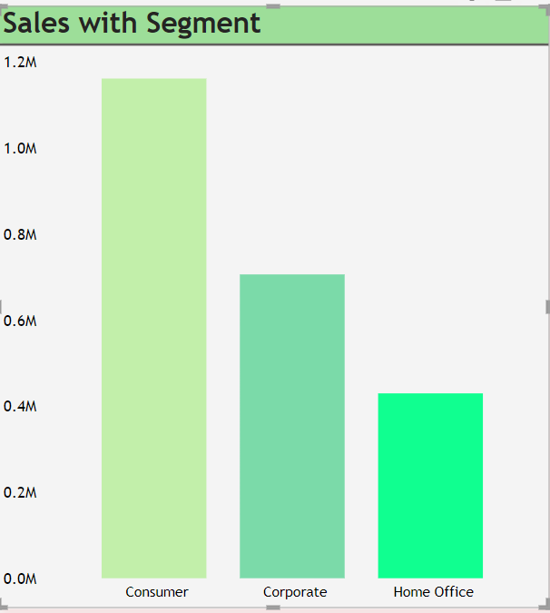

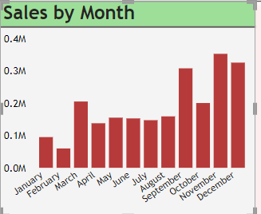

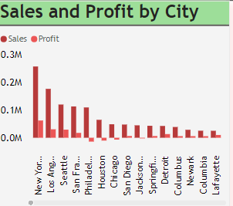

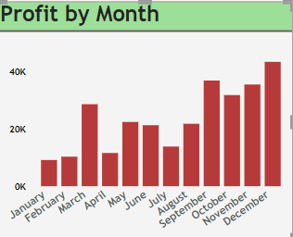

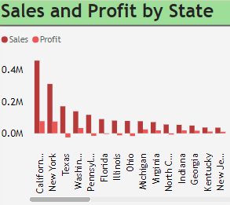

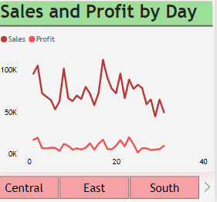

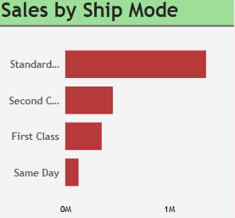

**Insights**

**Monthly sales performance:** September, November and December having the highest sales figure while February experienced a dip, emphasizing seasonal trend opportunities for optimization

**Segment wise Sales:** consumer segment having top number of sales as comparison with other

**Sales by Ship mode:** standard ship mode having maximum number Where same day having very low amount

**Monthly profit:** December and September month with highest profit while show very less profitability

**Sales by State**: California sand New York emerge as the frontrunners in terms of sales performances

**Conclusion**

**Recommendation:**

* Offer promotion during low sales to boost sales strategy
* Target those cities where we are lacking to get profited by implementing new strategy
* Working on festival offer for more engagement

The implications of these findings suggest that the company should focus on targeted marketing for high-performing customer segments and adjust inventory and promotional strategies to capitalize on seasonal sales patterns. Optimizing shipping strategies and addressing cost issues in lower-margin states can further enhance overall profitability.

Overall, the insights gained from this analysis offer actionable recommendations to improve sales performance and profitability, positioning the company for continued success.